**Technical Document**

**PmSystem:** It is a web project developed using the C# programming language. The project is structured in two applications: a frontend application that was developed with Blazor and a webApi application.

**Frontend:** The frontend application is the application responsible for interacting with the user. In this application the user can create, edit and delete products and customers.

**WebApi:** The Web Api application is the one that handles all the requests created by the users through the frontend application.

**The WebApi** uses swagger to provide all the documentation. related to how to consume the api from any interface.

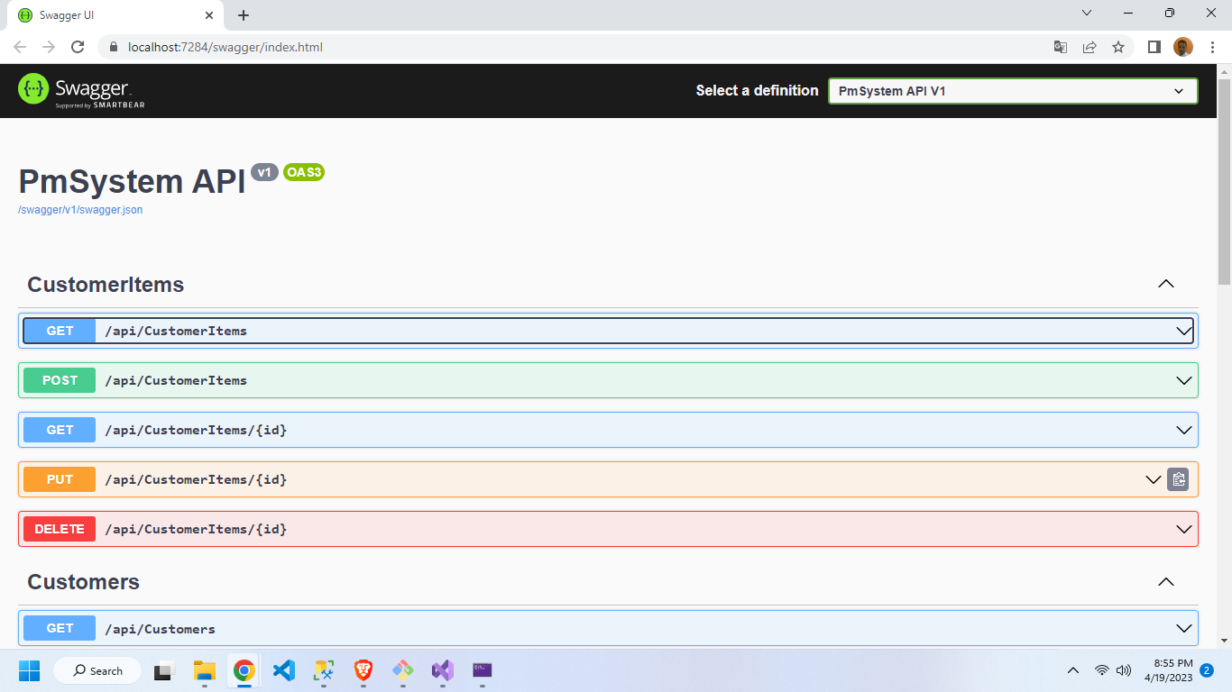

**Requirements:**

To run the project correctly you need to install the .Net 6 SDK (https://dotnet.microsoft.com/en-us/download/dotnet/6.0), have a Sql Server database server and have visual studio 2022 installed. You can use another visual studio but we do not recommend this option as it may cause errors.

**Tools:**

* Visual Studio 2022
* .Net 6 (.Net Core 6)
* git
* Entity FrameWork Core 7.0.5
* SQL Server
* C#
* Blazor
* FluentValidation 11.5.1

The architecture chosen for the development of the code was clean architecture.

Read more:

<https://en.wikipedia.org/wiki/Hexagonal_architecture_(software)>

Note: The project was developed using Dependency Injection so i you want to create another services and repositories go to: PmSystem.Infrastructure.Glue in inject all new dependency

